 NARROGIN SENIOR HIGH SCHOOL

English Foundation Year 11 (FEENG)

Student: Teacher: McWilliams Date Due: 15/05/2020

Assessment Type:

Task 3: Writing

Undertake an SWT analysis of selected images

Create visual and written documents and a composition which explain your interpretation of an image which comments on an issue or group.

Time allocation: 8 periods
Conditions: in-class
Weighting: 7%

Mark: / 100

To be assessed for this task you must submit: | Date Due | YES | NO
Completed Booklet | 8/05/2020
Poster | 15/05/2020

Teacher Comment:

Self-reflection
What three things did I do well?
What three things could I have done better?
What things could I do in class to help me improve for the next task?
What things could I do at home to help me improve for the next task?

Task

PART ONE:
Look at the following images and analyse them using the SWT codes:

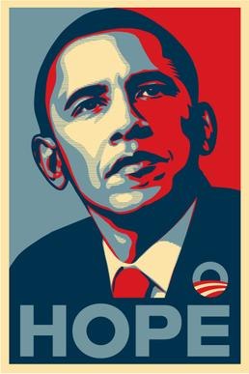

Symbolic (3 marks)

Written (3 marks)

Technical (4 marks)

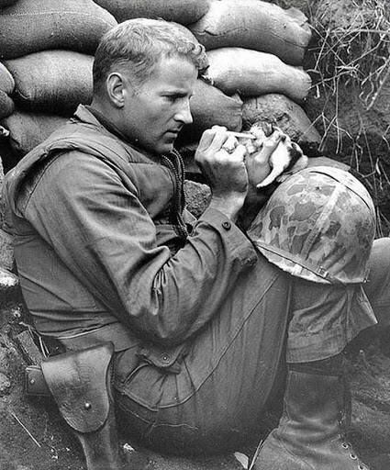
Symbolic (3 marks)

Written (3 marks)

Technical (4 marks)

PART TWO:

(
Context: The Power of Images
‘I Protest’: a local or community issue
Select an issue within your local or wider community which you believe has created a problem.

Some of the types of issues you may wish to address could be:

- Racial prejudice towards a minority group;
- Unfairness in access to facilities or opportunities;
- Need for improvement in the management of a local service or facility;
- A specific form of mistreatment of animals;
- Vilification of asylum seekers/refugees;
- Discrimination towards older people;
- Discrimination towards younger people; or
- Lack of understanding/prejudice towards people with disabilities/specific conditions.

You are able to research an alternative topic provided you gain approval in advance.

Prepare a poster outlining your concerns about this issue and challenging people to think differently about the problem.

Make sure to use of the SWT codes in designing your poster. Please also include an explanation of what techniques you have used in constructing your poster (minimum half a page).

Part B - Assessment Criteria

Criteria | The Response | Marks
Intellectual appeal of material | presents a totally convincing conceptual perspective on the issue | 9-10
Intellectual appeal of material | creates a positive conceptual impression | 7-8
Intellectual appeal of material | engages the reader’s/viewer’s attention to the argument | 5-6
Intellectual appeal of material | presents some valid points of the argument | 3-4
Intellectual appeal of material | presents an unconvincing argument | 1-2
Emotional appeal of material | effectively uses emotional appeal to totally sway the reader | 5
Emotional appeal of material | appeals to the emotions with some success | 4
Emotional appeal of material | has some emotional appeal | 3
Emotional appeal of material | is emotive without appealing to the emotions | 2
Emotional appeal of material | lacks emotional appeal | 1
Use of conventions for the selected genres | demonstrates complete mastery of the associated generic conventions | 5
Use of conventions for the selected genres | uses several conventions in effective ways | 4
Use of conventions for the selected genres | uses several conventions | 3
Use of conventions for the selected genres | abides by one or two conventions | 2
Use of conventions for the selected genres | pays little regard to the conventions of the genre | 1
Choice of expression | uses lively vocabulary and interesting phrasing to effectively engage the reader | 5
Choice of expression | engages the reader through choice of expression | 4
Choice of expression | shows some thought in choice of expression | 3
Choice of expression | uses a bland and limited vocabulary | 2
Choice of expression | uses expression that is inadequate for the task | 1
Control of grammar | makes effective use of grammar to persuade the reader | 5
Control of grammar | exhibits correct grammar throughout | 4
Control of grammar | shows reasonable control of grammar | 3
Control of grammar | makes a few grammatical errors | 2
Control of grammar | lacks grammatical control | 1
Use of punctuation | uses punctuation in innovative and effective ways | 5
Use of punctuation | always uses punctuation correctly | 4
Use of punctuation | frequently uses punctuation correctly | 3
Use of punctuation | uses some punctuation correctly | 2
Use of punctuation | uses punctuation ineffectively | 1
Spelling | spells all words correctly | 5
Spelling | spells key words correctly and minimises minor errors | 4
Spelling | spells key words correctly but makes some minor errors | 3
Spelling | includes few examples of correct spelling | 2
Spelling | Does not meet the requirements of a D grade. | 1
 | Part A | 20
 | Part B | 40
 | TOTAL | 60
 | Mark converted to percentage | %

